BUSINESS INTELLIGENCE LAB
EXPERIMENT 5
Report Generation using Relational and Multidimensional Data using Microsoft Power BI
Stepwise Document

SUBMITTED BY- SUBMITTED TO-
Name: Yashika Dagar Name: Ashiq Nazir Bhat
UID: 24BAI70566

1. Aim
To generate relational and multidimensional reports using Microsoft Power BI by utilizing transactional and dimensional data models, enabling effective business analysis, reporting, and decision-making.

2. Tools / Software Required
- Microsoft Power BI Desktop
- Global Superstore Dataset.xlsx
- Power Query Editor
- DAX (Data Analysis Expressions)

3. Dataset Source and Fields
Dataset: Global Superstore Dataset (Kaggle).
Source URL: https://www.kaggle.com/datasets/apoorvaappz/global-super-store-dataset
Fields used in this experiment include Order ID, Customer Name, Product Name, Region, State, City, Sales, Profit, Quantity, Category and Order Date. Exact field availability may depend on the version of the workbook loaded.

4. Procedure

Part A — Generate a Relational Report
Step 1. Open the existing Power BI Desktop project containing the Global Superstore data. If the data is not loaded, use Home → Get data → Excel workbook, select Global Superstore Dataset.xlsx, and load the relevant sheet/table.
Step 2. Go to Report view and click a blank area of the report canvas.

Step 3. From the Visualizations pane, select the Table visual.

Step 4. Drag Order ID, Customer Name, Product Name, Region, Sales and Profit from the Data pane into the table. Power BI may summarize numeric fields as Sum; retain the aggregation when the purpose is to show summarized values, or change it where transaction-level values are required.
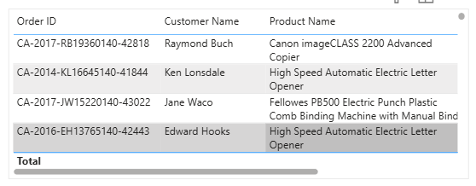

Step 5. Resize the table so that all selected columns are readable. Rename the visual title to Relational Transaction Report using Format visual → General → Title.

Step 6. To sort, select the table and click the Sales column heading. Toggle the heading until the required ascending or descending order is displayed.

Step 7. To filter the table, select the table visual. In Filters on this visual, expand Region and select a region value (for example, Western US if present in the loaded data). The table will show records matching the selected filter.

Step 8. To export, select the table visual, click the More options (…) menu, choose Export data, select the required file format (for example, .xlsx if offered, otherwise .csv), and save the exported file.
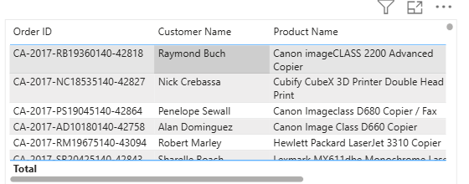
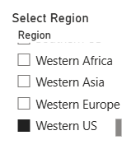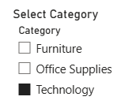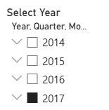

Part B — Generate a Multidimensional Report
Step 1. In the Data pane, right-click the Region field and select New hierarchy. Power BI creates a hierarchy containing Region.

Step 2. Rename the hierarchy to Region Hierarchy if required.

Step 3. Drag State onto the newly created hierarchy, below Region. Drag City below State. Confirm the order is Region → State → City.

Step 4. Click a blank area of the report canvas and select the Matrix visual from the Visualizations pane.

Step 5. Drag Region Hierarchy into the Rows well of the Matrix.

Step 6. Drag Sales, Profit and Quantity into the Values well. Check that the numeric fields use Sum aggregation.

Step 7. Resize the Matrix and expand/collapse the hierarchy using the plus/minus icons beside row labels.

Step 8. Use the visual header drill controls to drill down from Region to State and then City. Use Drill up to return to a higher level. If the drill controls are not visible, enable the visual header options or use the expand icons in the matrix.
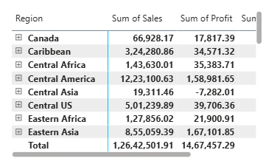

Part C — Comparative Analysis Report
Sales by Category: Insert a Clustered column chart. Add Category to the X-axis and Sales to the Y-axis (Sum). Set the title to Sales by Category.
Profit by Region: Insert a Clustered bar chart. Add Region to the Y-axis and Profit to the X-axis (Sum). Set the title to Profit by Region.
Top 10 Customers by Sales: Insert a bar chart. Add Customer Name to the Y-axis and Sales to the X-axis. In Filters on this visual, change Customer Name to Top N, enter 10, place Sales in By value, and select Apply filter. Sort by Sales descending and title the chart Top 10 Customers by Sales.
Year-wise Sales Trend: Insert a Line chart. Add Order Date to the X-axis and Sales to the Y-axis. Use the date hierarchy and retain the Year level on the X-axis. Set the title to Year-wise Sales Trend.
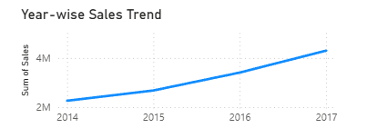

Part D — Create an Interactive Dashboard
Step 1. Insert a Card visual. Add Sales and ensure the aggregation is Sum. Set the title to Total Sales.
Step 2. Insert a second Card visual. Add Profit with Sum aggregation and title it Total Profit.
Step 3. Insert a third Card visual. Add Order ID and change its aggregation to Distinct count (not First or Count) so that each unique order is counted once. Set the title to Total Orders.
Step 4. Insert a Slicer visual and add Region. Repeat to create another slicer for Category.
Step 5. Insert a third Slicer and add Order Date. If Power BI inserts Date hierarchy, use its field dropdown to select Year so that the slicer filters by year.
Step 6. Arrange the KPI cards at the top and slicers along one side or across the top. Place the charts and Matrix neatly below them. Add a text box heading such as Global Superstore Dashboard.
Step 7. Test each slicer by selecting a Region, Category and Year. Confirm that the KPI cards and relevant charts update. If a visual does not respond, select the slicer and use Format → Edit interactions to check that the filter interaction is enabled for that visual.

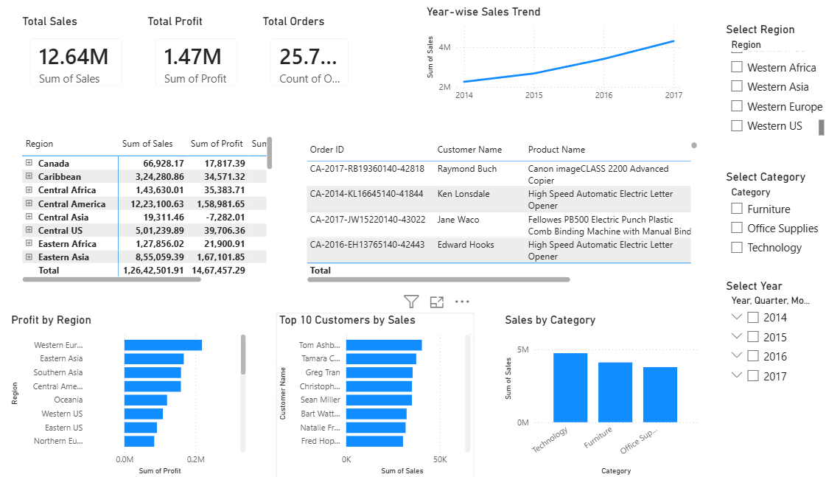

5. Observations
- The relational table displays selected transaction fields and supports sorting and filtering for record-level inspection.
- The Matrix summarizes Sales, Profit and Quantity across the Region → State → City hierarchy.
- Drill-down reveals more detailed geographical performance, while drill-up returns to summarized results.
- The category, region, customer and year visuals provide different views of sales and profitability.
- KPI cards summarize key measures, while slicers allow users to interactively filter the report.

6. Result
Relational and multidimensional reports were created in Microsoft Power BI using the Global Superstore dataset. A comparative analysis page and an interactive dashboard with KPI cards and slicers were prepared.

